**Setting Up the Foundational Virtual Network Lab:**

**Overview**

I am currently working on the first stage of setting up a fully functional Virtual Network Lab. This lab will provide a safe environment for practical cybersecurity training. It is built using VirtualBox, which I use to manage all my virtual machines. So far, I have installed three main systems: two Windows 8 machines and one Windows Server. My next step is to connect these virtual machines into a single network, similar to setting up the basic wiring in a real office.

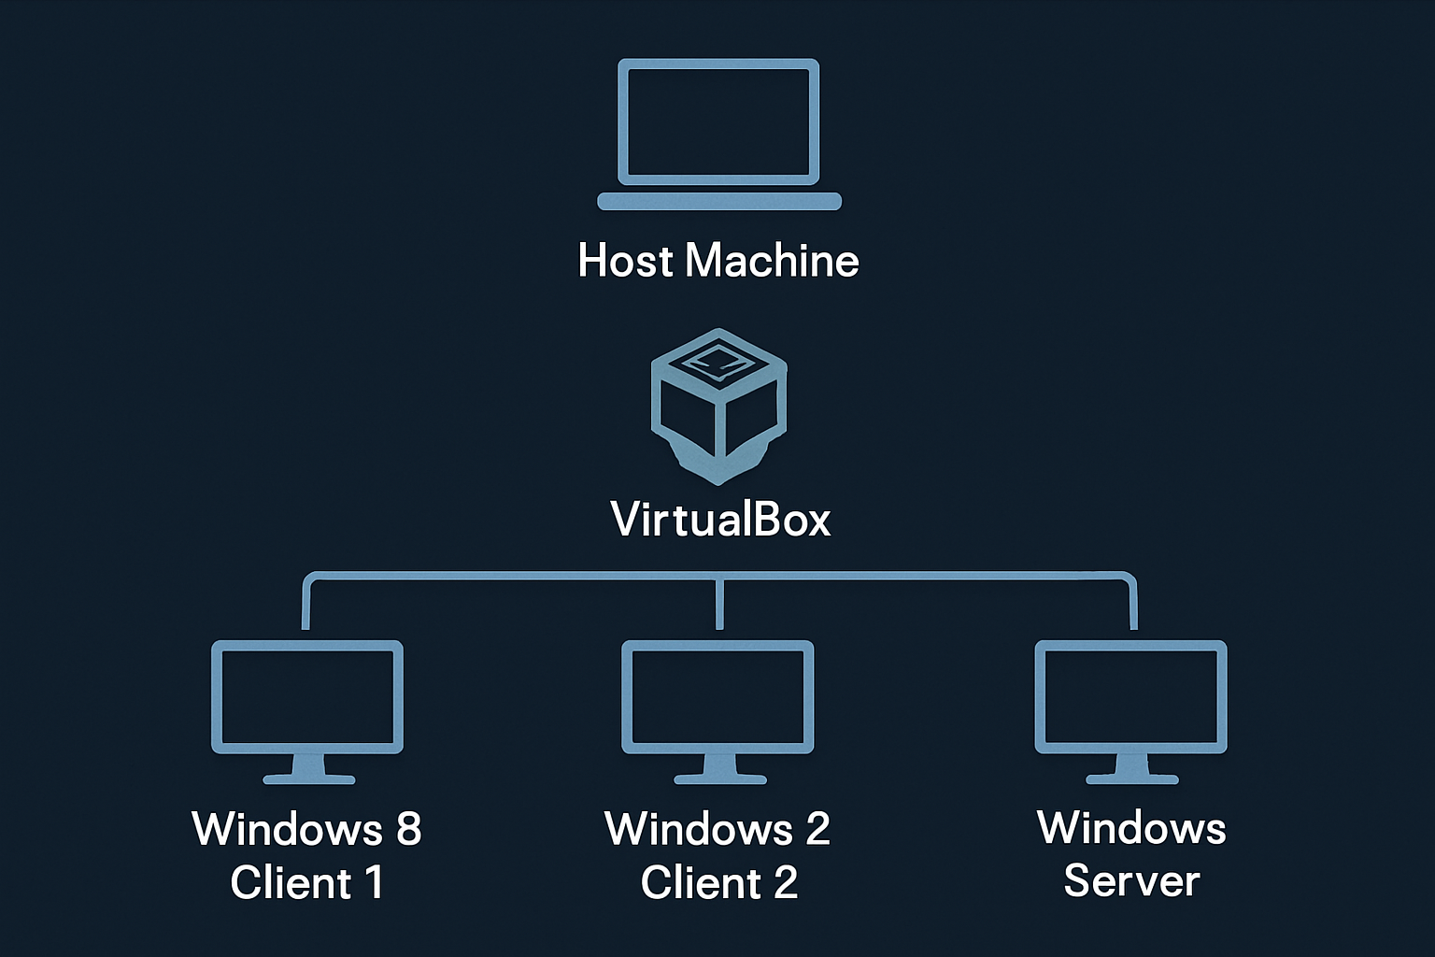

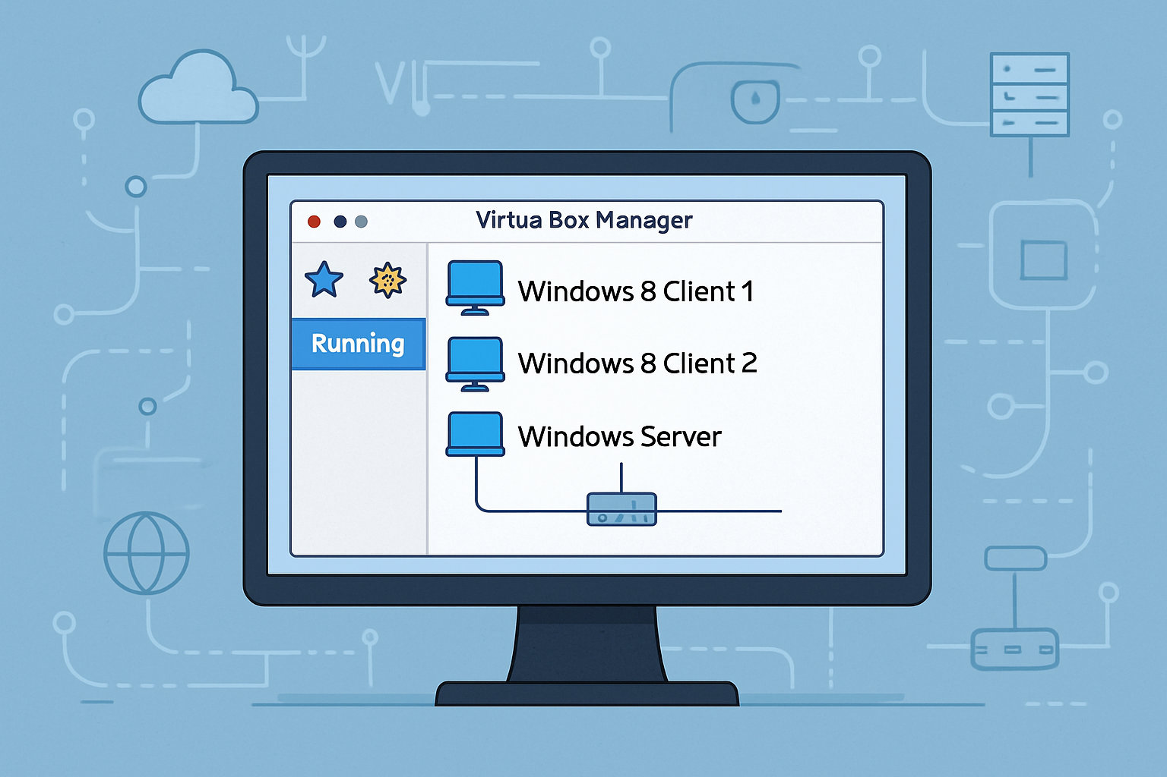

Let me walk you through how the downloads and installations were done;

**Phase 1: Downloading the VirtualBox Platform Package**

The first step is to visit the official VirtualBox download page and select the appropriate platform package.

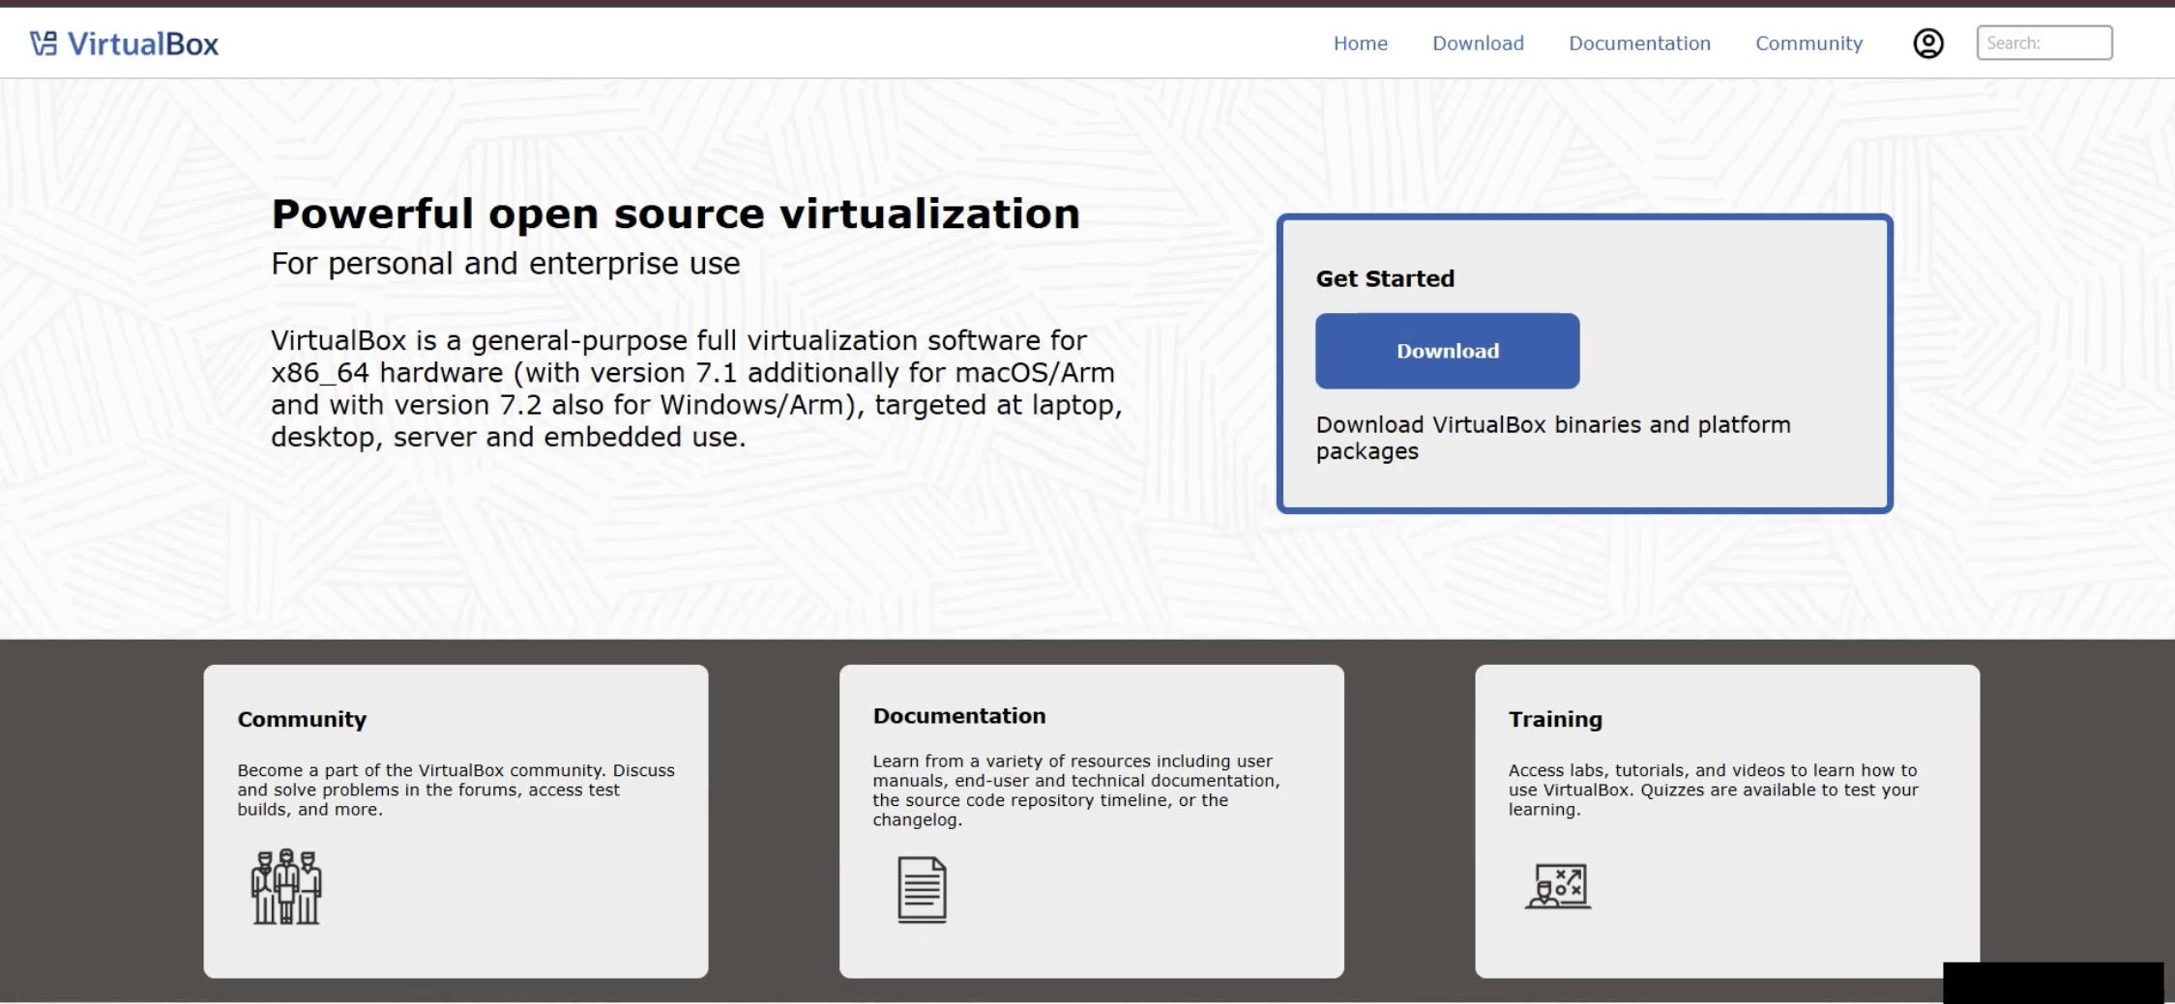

And scroll down the page to select the installer that matches my primary computer.

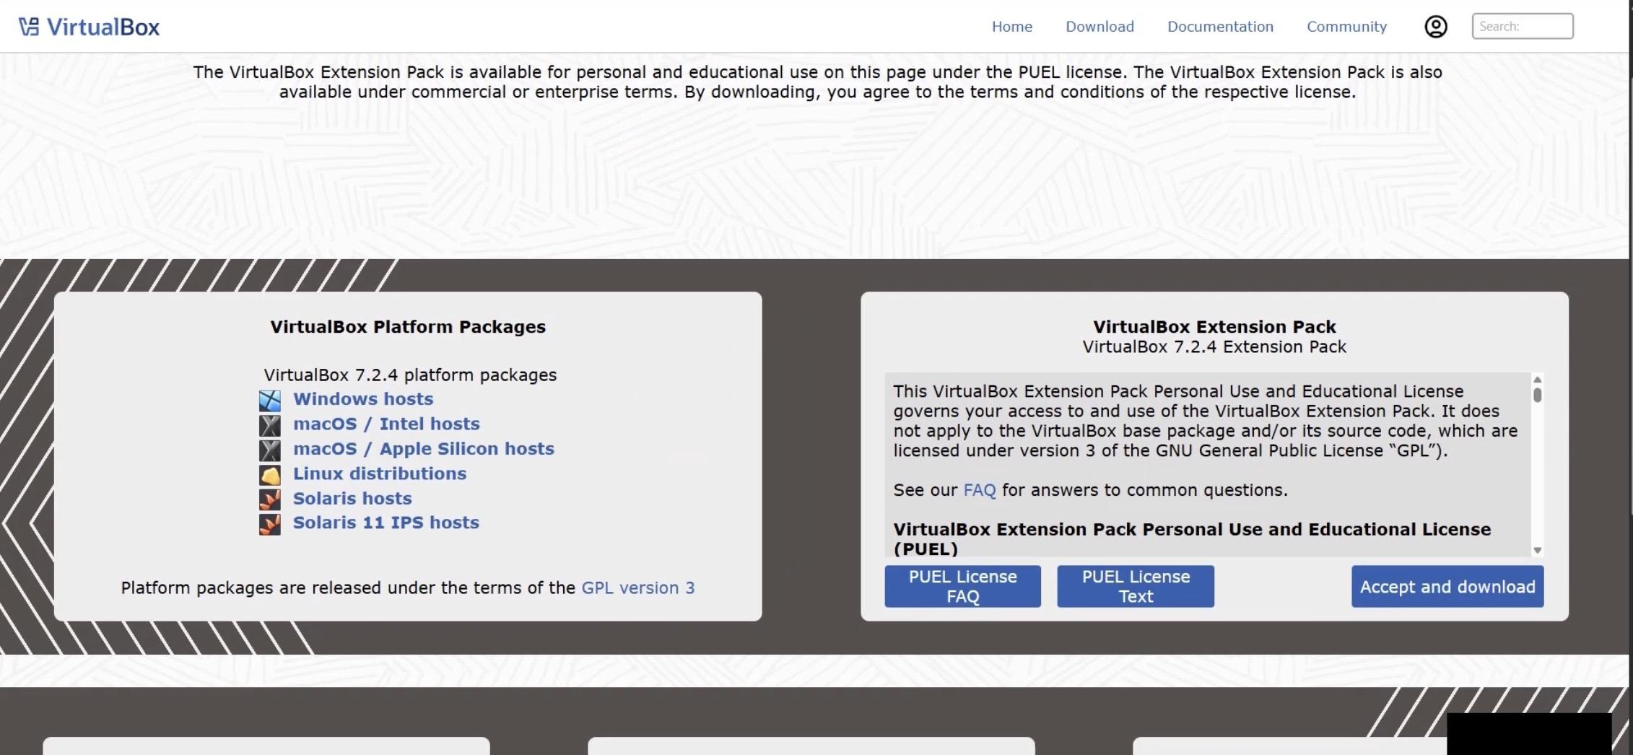

I selected the **Windows hosts** option, which initiated the download of the VirtualBox executable (.exe) file. This package serves as the core component for building my virtual lab environment.

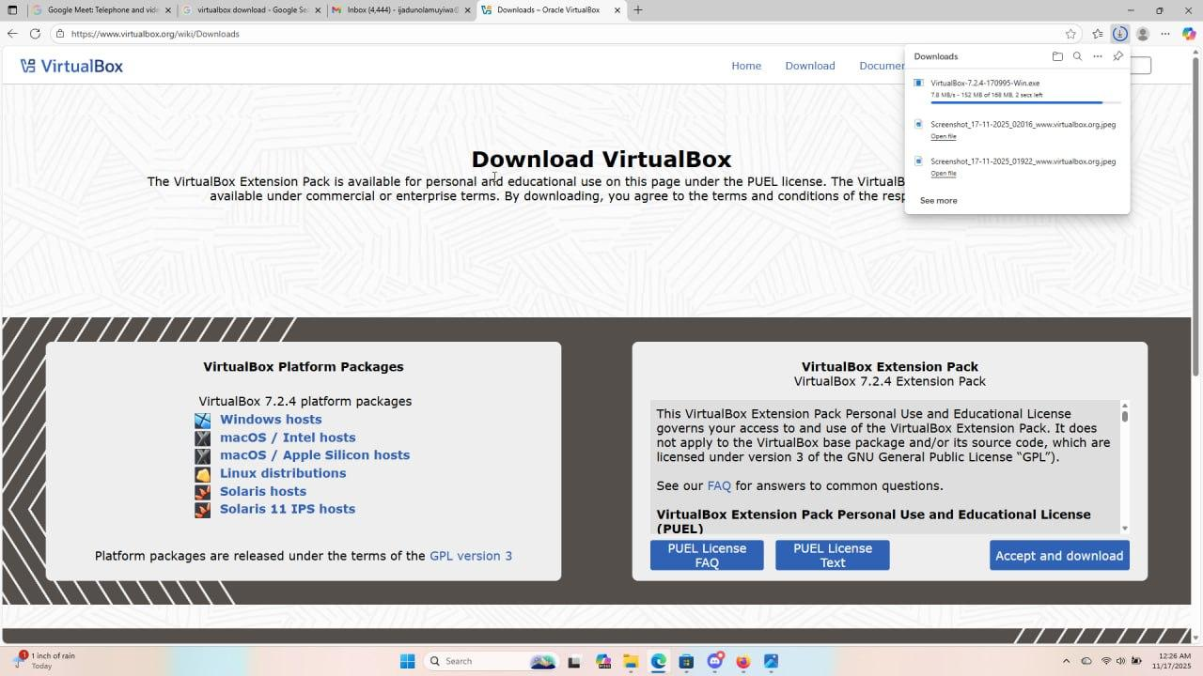

Once the download is complete,



I launched the executable to begin the installation process, which opened the screen titled **“Welcome to the Oracle VM VirtualBox Setup Wizard.”**

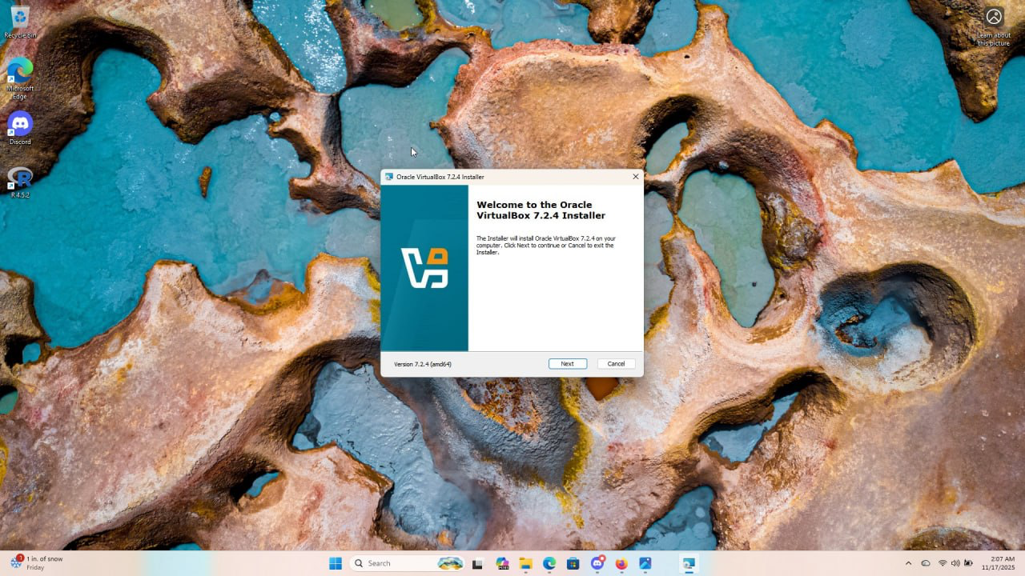

Then, I clicked next and I got the license agreement page.

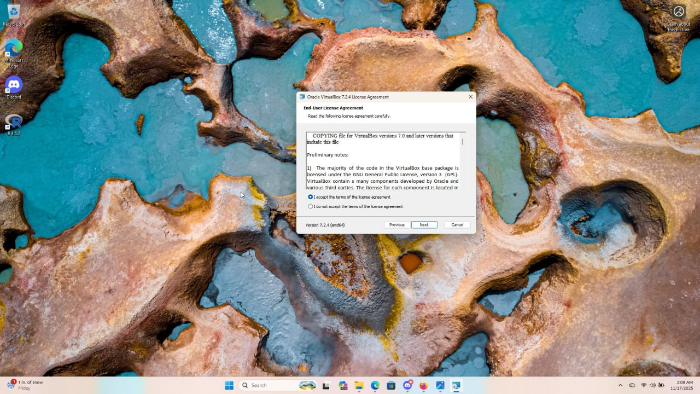

I accepted the prompt and proceeded by clicking **Next**. On the following screen, I was given the option to change the installation directory, but I kept the default location and continued by selecting **Next** again.

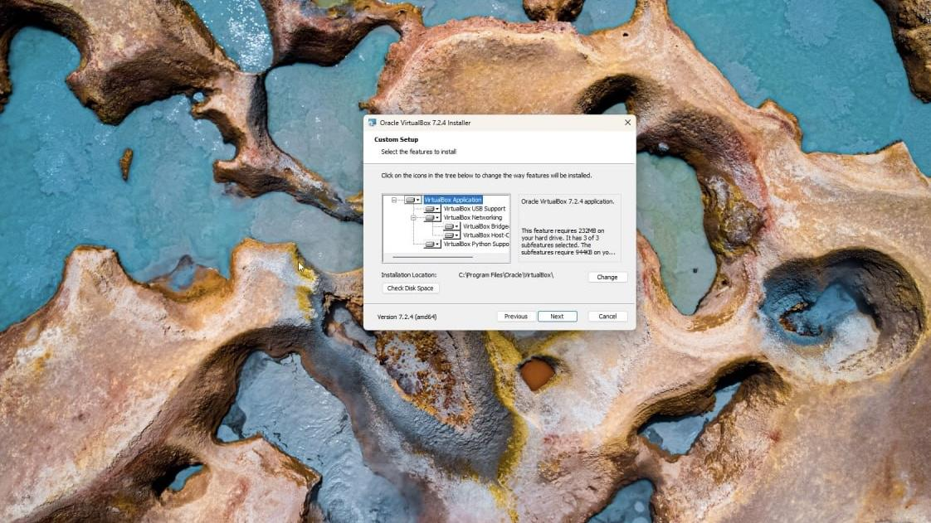

I got the warning page and after going through it, I clicked yes.

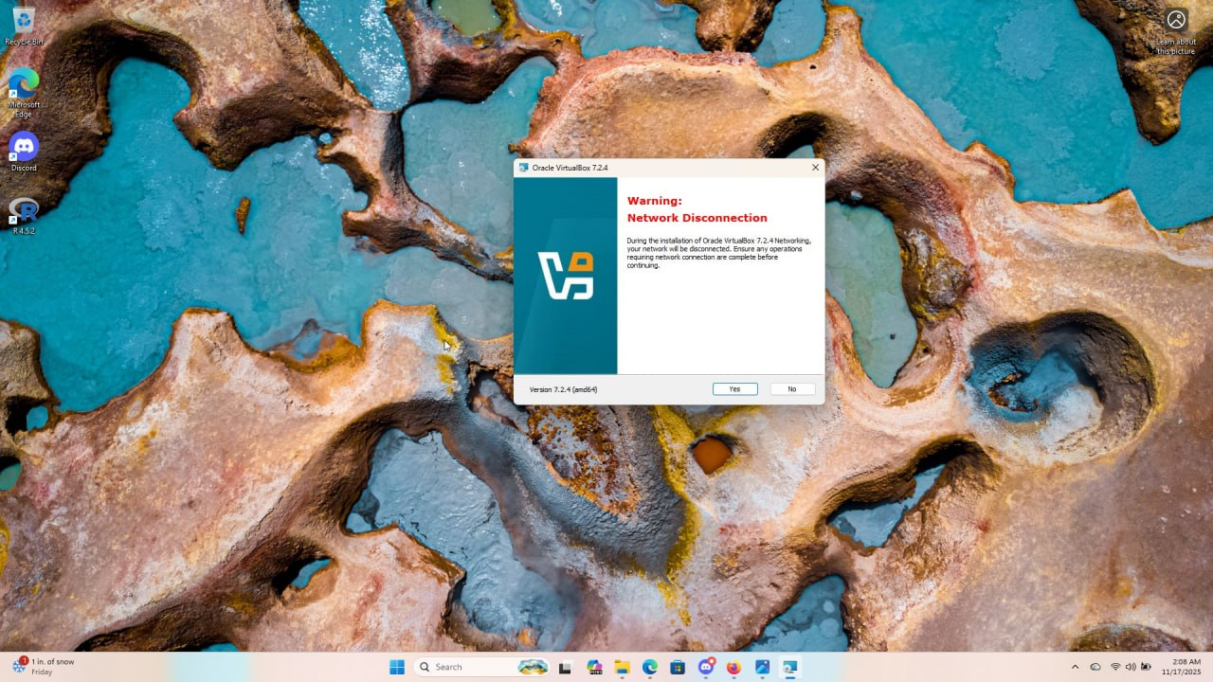

The next screen appeared, and after reviewing the information, I selected **Yes** to allow the installation of the required dependencies.

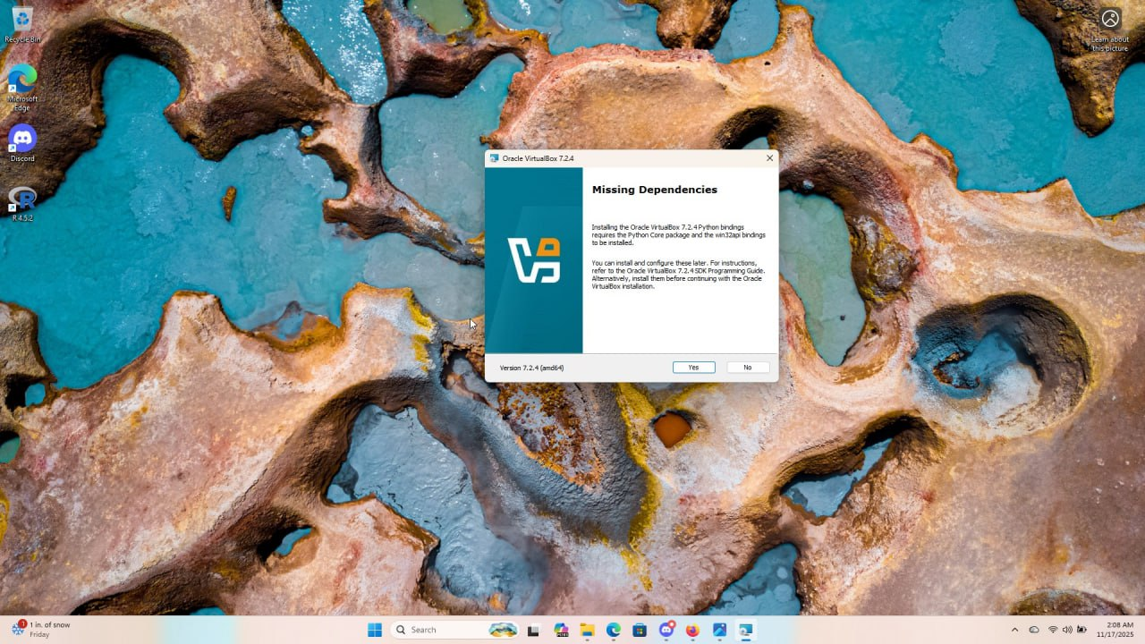

Once the missing dependencies were installed, I proceeded to the feature selection screen. I chose all available features and clicked *Next* to continue.

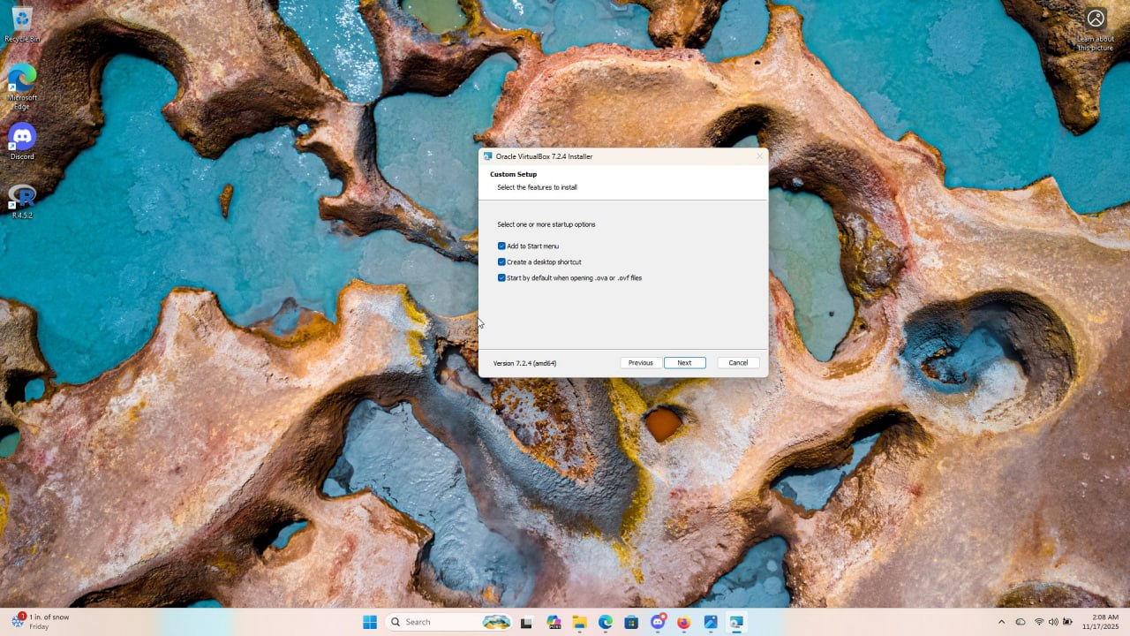

I was then taken to the final installation screen, where I clicked **Install** to begin the setup process.

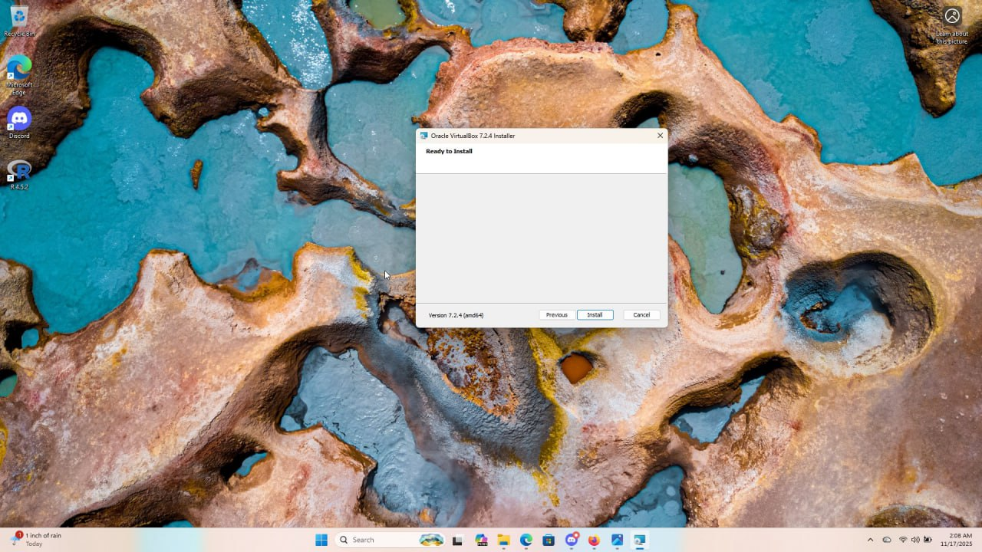

I clicked next and the installation began

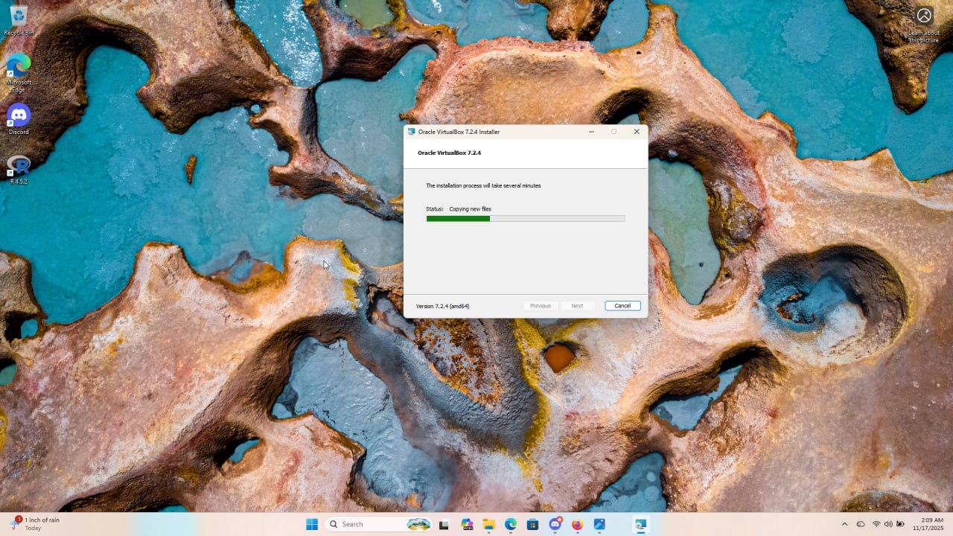

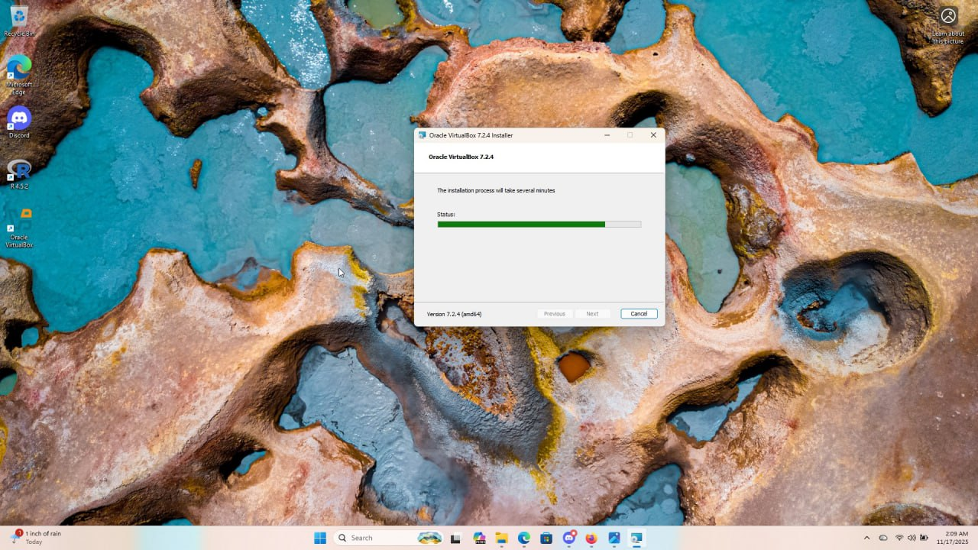

Then the installation of the VirtualBox was completed and I clicked finish.

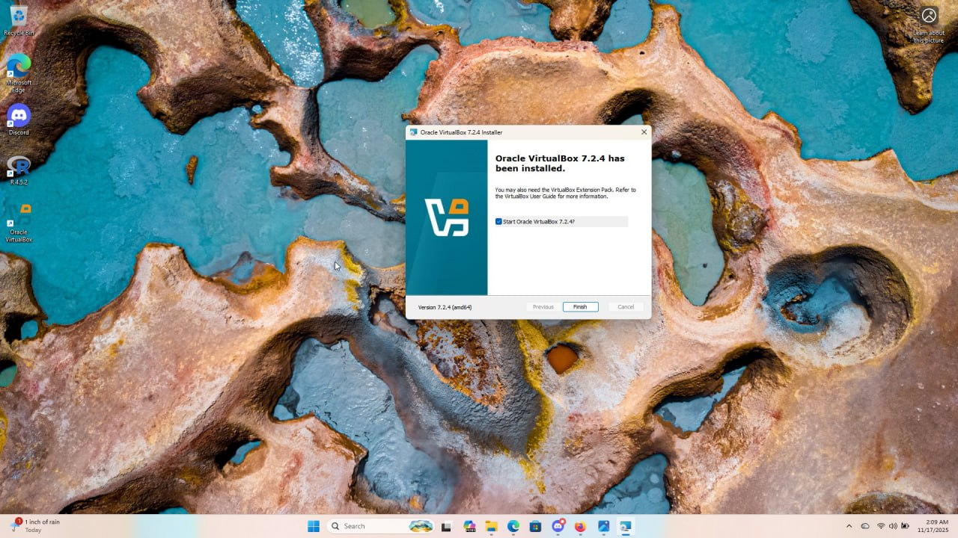

This is what I got when I opened my virtual machine

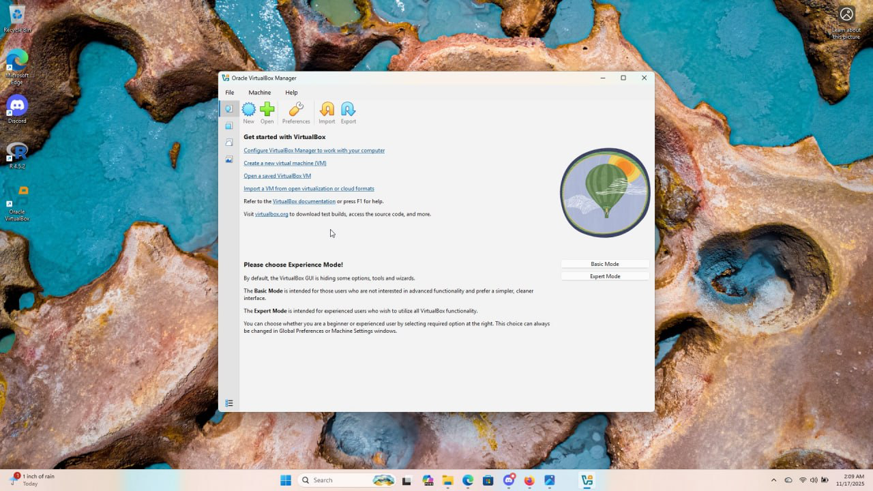

**Phase 2**: **downloading and installing the Windows Server on the VM**

Stage 1: I utilized Google Search to find the installation media for a modern, relevant operating system, selecting Windows Server 2022.

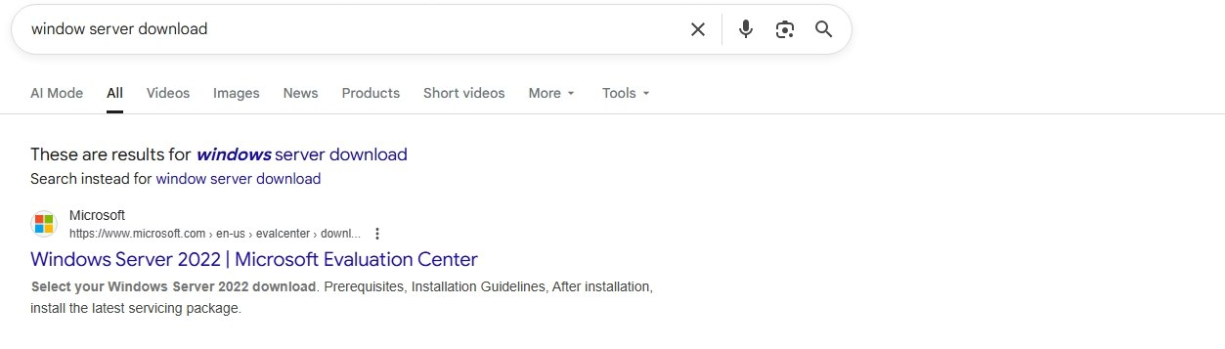

Upon reaching the download page,

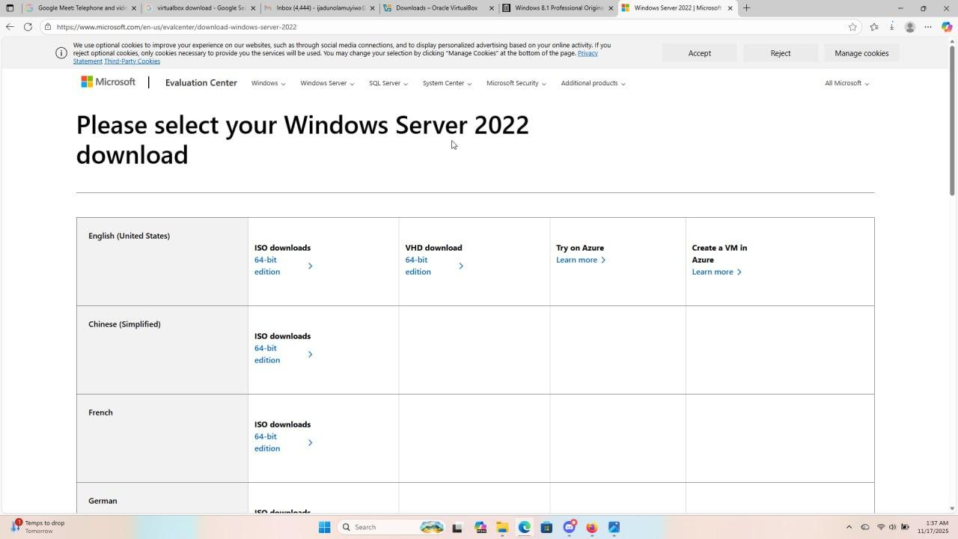

I selected the 64-bit edition.

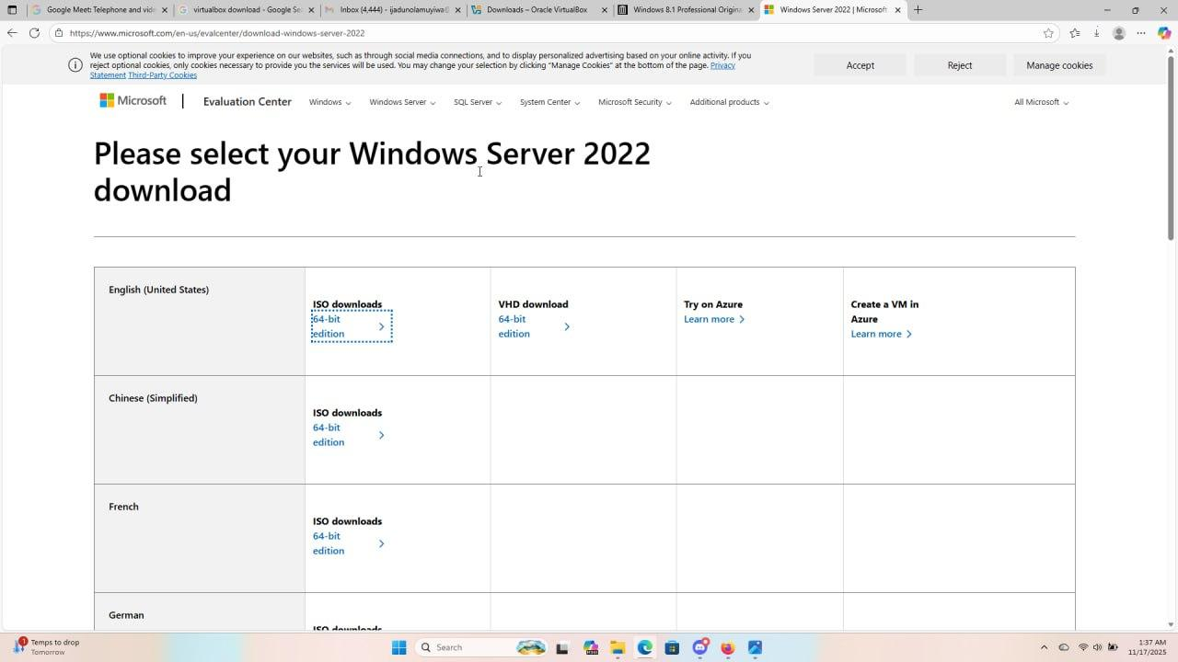

After confirming my selections, the download of the Windows Server 2022 ISO image began and completed successfully.

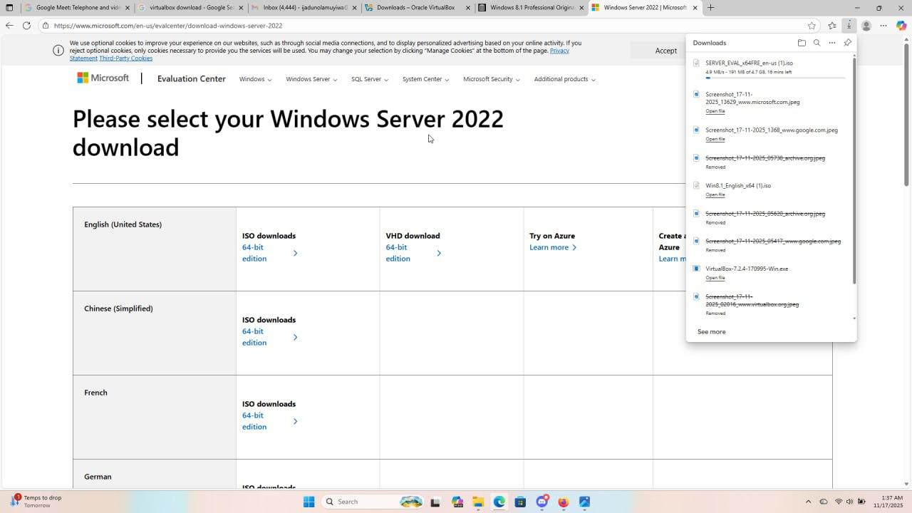

**Stage 2:** With the server software downloaded, the next step was to return to VirtualBox to create the virtual machine. In the VirtualBox Manager, I selected the **“New”** button, which initiated the setup process. From there, I began assigning virtual resources, including the amount of RAM and hard disk space needed for the new Windows Server system.

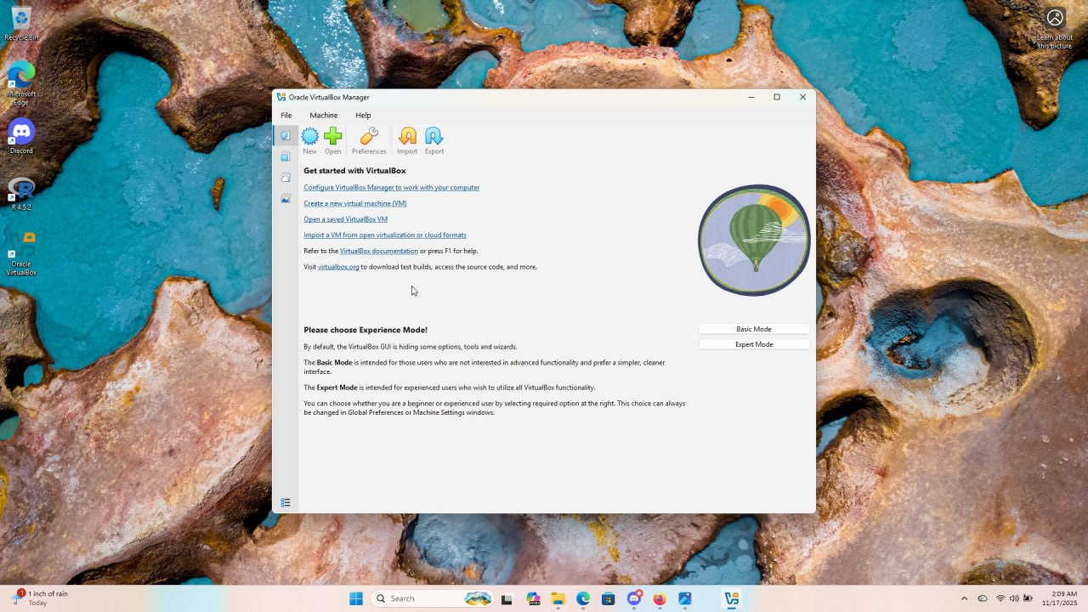

Here’s a refined version:

The final step in this stage was to mount the newly downloaded Windows Server 2022 ISO file. Mounting simply means attaching the ISO essentially to a virtual DVD to the virtual machine I created. This enables the VM to detect the operating system installer and begin the setup process once it is powered on.



After clicking the “new”, I have a page that involves dedicating specific virtual hardware resources to the new server.

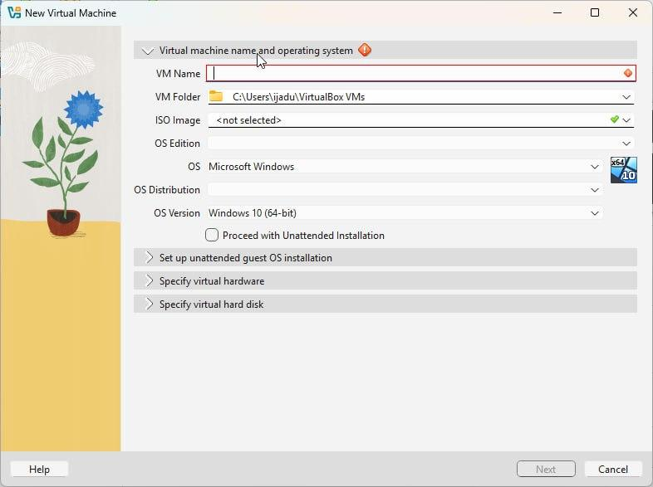

I started by assigning a logical name to the virtual machine, which I labeled **“Windows Server new.”** I then selected the ISO Image option, located the file named **“SERVER_EVAL_x64FRE_en-us (1)”** in my downloads folder, and attached it. I chose not to enable the unattended installation option.

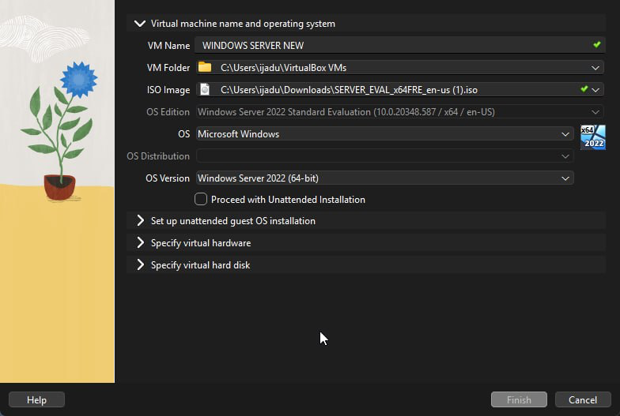

Next is configuration of the virtual hardware parameters, where I assigned 4096 GB (Gigabytes), for the Virtual Processors (CPUs), I assigned 4 processors, for the Virtual Hard Disk: I allocated 50 GB of virtual storage,

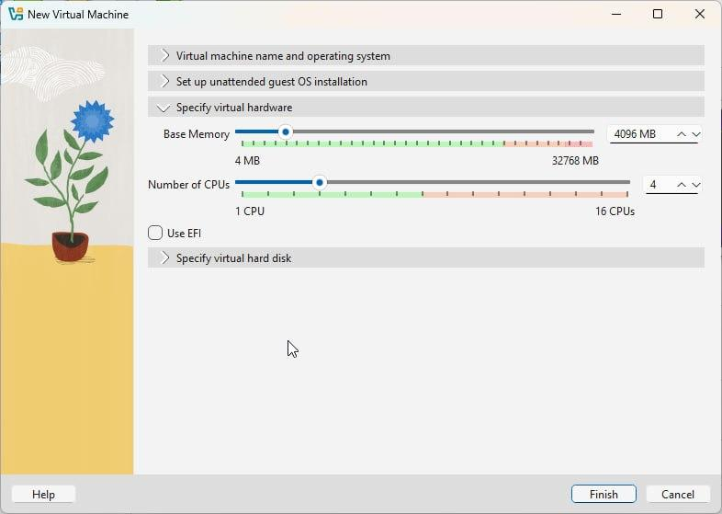

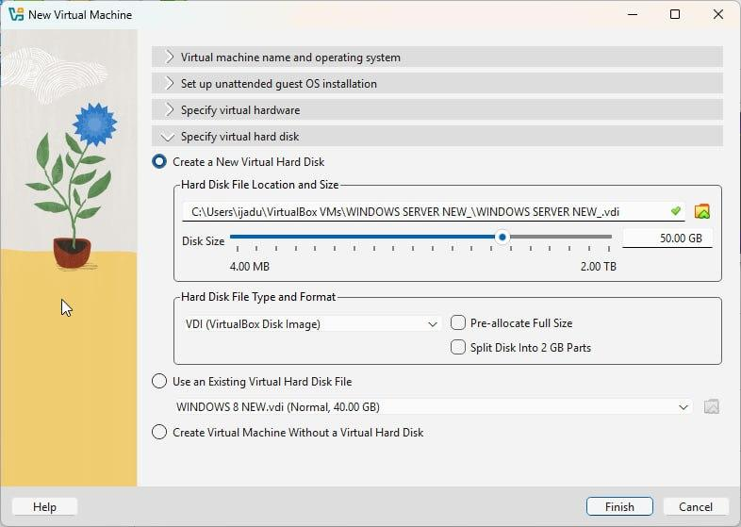

After Completion: By clicking "Finish," the definition of the Windows Server VM was complete, and the machine was ready to be powered on to begin the formal operating system installation.

**Phase 3: Downloading and installing the Windows 8 file on VMs**

This phase focuses on acquiring and configuring the standard client operating systems.

Stage 1: Downloading of Windows 8 file

I initiated a search to find the iso file for Windows 8.

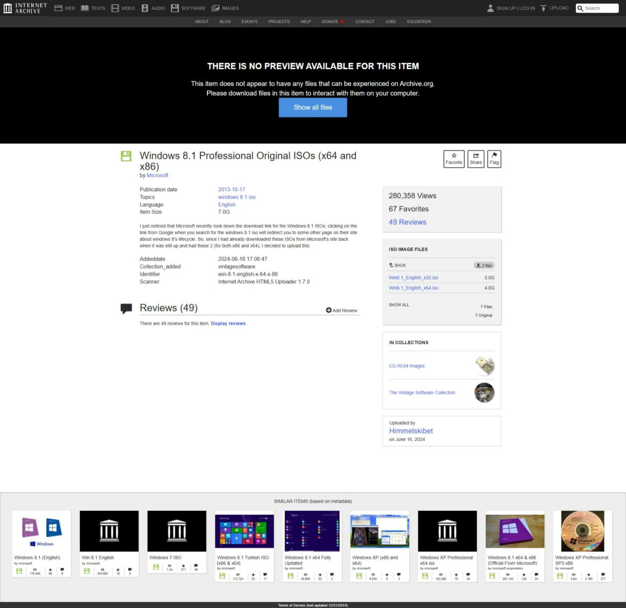

Upon locating the download source, I ensured the selection was the 64-bit edition. Then I clicked download

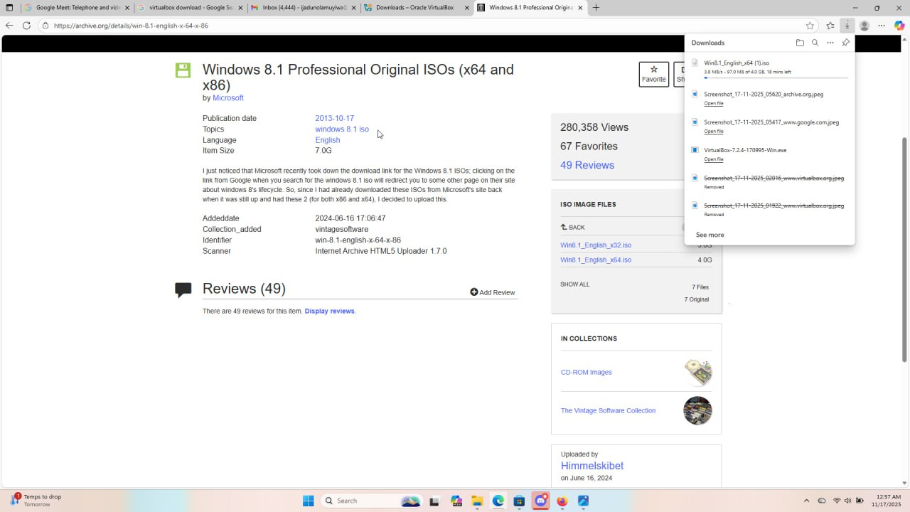

The process concluded with the successful download of the Windows 8 image file (the ISO file), making the software ready for use in VirtualBox.

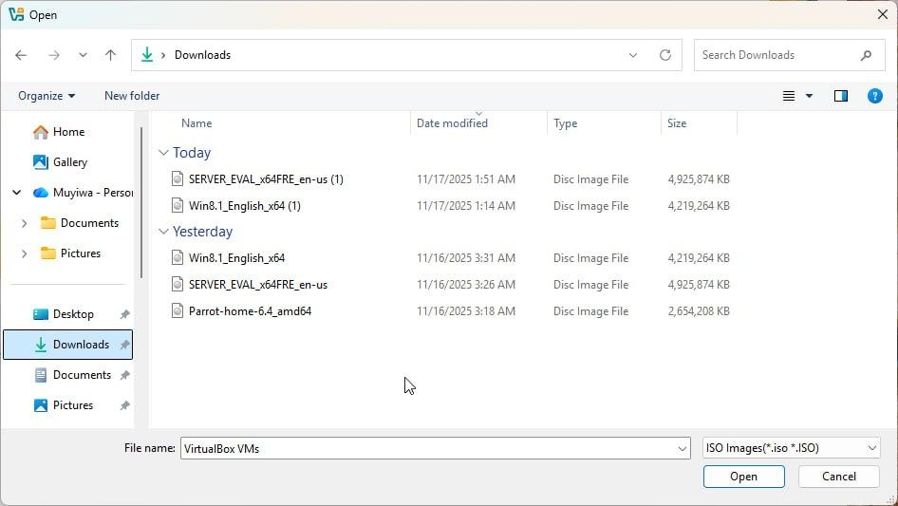

Stage 2: Creating and Configuring the Windows 8 VM

With the Windows 8 software ready, you returned to the VirtualBox Manager to define the machine that will run it. This process was then repeated for the second Windows 8 VM.

I clicked "New" in VirtualBox and initiated the setup process for the first window 8



I assigned a virtual Name for the first client to be “Windows 8 New”

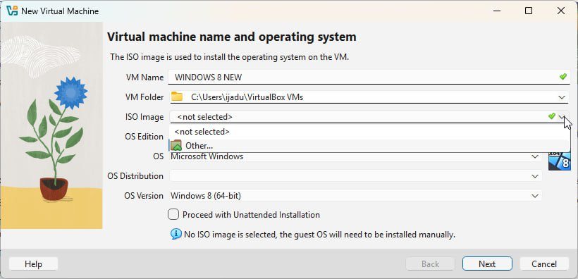

and successfully mounted (connected) the downloaded Windows 8 ISO file to the new virtual machine.

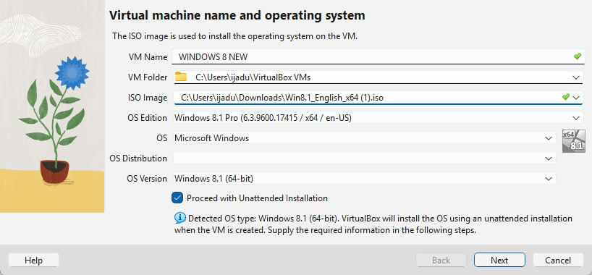

I correctly chose to Skip Unattended Installation to maintain full control over the setup.

I defined the robust virtual hardware settings for the client VM to ensure smooth operation. I allocated 2 GB of RAM and 4 processors.And for the virtual hard disk, I allocated 40 GB of virtual storage space.

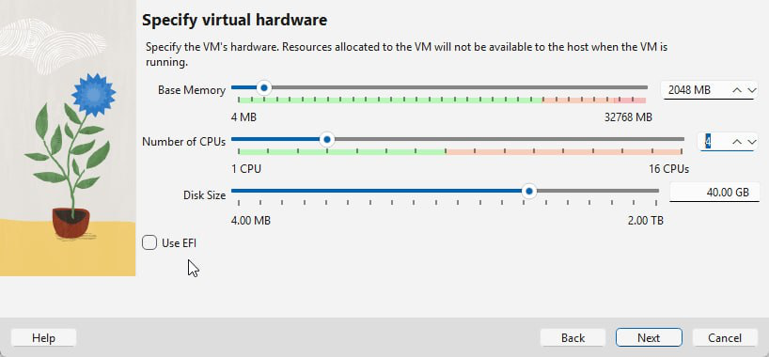

By clicking “Next” and then "Finish," the configuration for the first Windows 8 VM was saved.

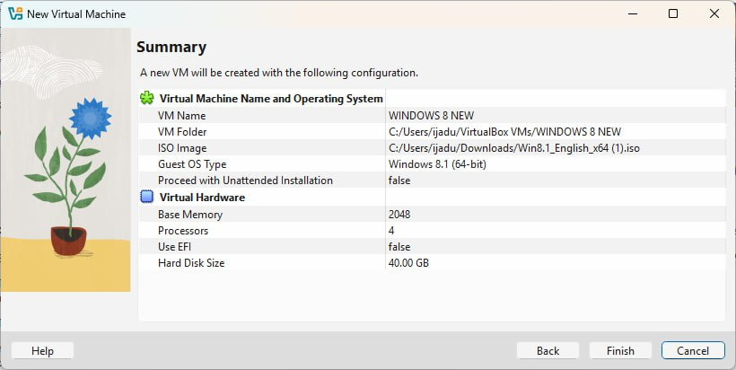

I Repeated the whole process for “Windows 8 New 2 “. I have now documented the successful acquisition and provisioning of all four virtual machines, Windows Server, and both Windows 8 clients.